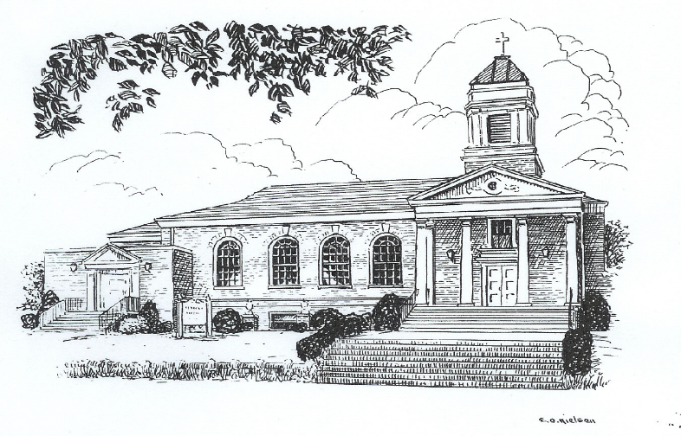
January 2023

Messenger
Methodist
Hartsville United Methodist Church
224 River Street, Hartsville, TN 37074
615-374-2400 www. hartsvilleumc.org
A Word from Pastor Tim:
“Here I am, Lord. Is it I, Lord? I have heard you calling in the night.
I will go, Lord, if you lead me. I will hold your people in my heart.” Here I Am, Lord by Dan Shutte

﻿ The Christmas season has come and gone. Although Christmas continues until January 6, for most people, this holiday season is a thing of the past. They are moving forward into the new year. And what will you take with you into the new year?
Did you engage in the advent devotional with us? Will you continue reading a devotional of some sort each day? Did you read a chapter of scripture leading up to Christmas? Will you continue reading scripture each day? Did you find yourself coming to church more, thinking of your faith more, being revived in your faith, etc.? Are these attitudes and activities that you will pack away to your attic or basement along with the tinsel and mistletoe?
One of the central themes of Christmas is giving gifts. We give gifts to our kids, but also to friends and even strangers. That’s right, strangers. At Christmas time we often go the extra mile to clothe the needy, feed the hungry, and give to bless those less fortunate. Maybe these people needed your gift. But perhaps they just needed to know someone cared enough to give them the gift. If they needed that in December, do you think they still need that in January?
The truth is, when you give to those in need such as our food boxes or gifts to an angel tree, the people know that you are giving to them because it’s Christmas time. Unfortunately, that may leave them wondering why you don’t care anything about them the rest of the year. What if we, as a church, decided to give to these people all year, long? “Pastor, certainly, you’re not implying that we can afford to give them a food box every month of the year?!?!” No, I am not. But we are not a feeding ministry, we are a church. Food is not the most valuable thing we have to offer, relationship is.
Was there a neighbor, friend, or even a stranger that you were extra nice to this Christmas season? How can we take them with us into the new year? Can we continue to visit with them monthly, pray with them, and share our lives with them? You cannot care for the entire community. But you can add one friend into your life. And in doing so, collectively, we can care for the community. Who did you meet in your giving and serving this holiday season that you are going to refuse to pack away with the tree, but instead, take with you into the new year? A. W. Tozer said, “Christians don’t tell lies, they just go to church and sing them.” Will we live the words of the song above… or just sing it when we gather?

Prayer List

The backbone of a church is prayer. Place this somewhere you will see it often. Then let every sighting be a reminder to pray for these. Please update the church on those on this list and others that need to be added.
Charlotte Dies (home on hospice) | Curtis Butcher (Cancer)
Connor Brown | Richard Robertson
Maxton Hawkins | Rosemary Denham
JoAnn McEvoy Family | Jenny Bradshaw (Cancer)
Jim Hunt | Bert Gammons (Multiple Health Issues)
JoAnne Kelley (Senior Living Center) | Beth Rolin (Cancer)
Mary Howell | Jill harper (leukemia)
Zoe Rose (Heart Condition) | Ann Thurman (Cancer)
Laura Marshall (Cancer) | Shannon Satterfield (Medical Issues)
Helen & Don Voss (Health) | Alice White
Alice Livingston | David Parker
Jessica Spicer (cancer) | Peggy Daniels

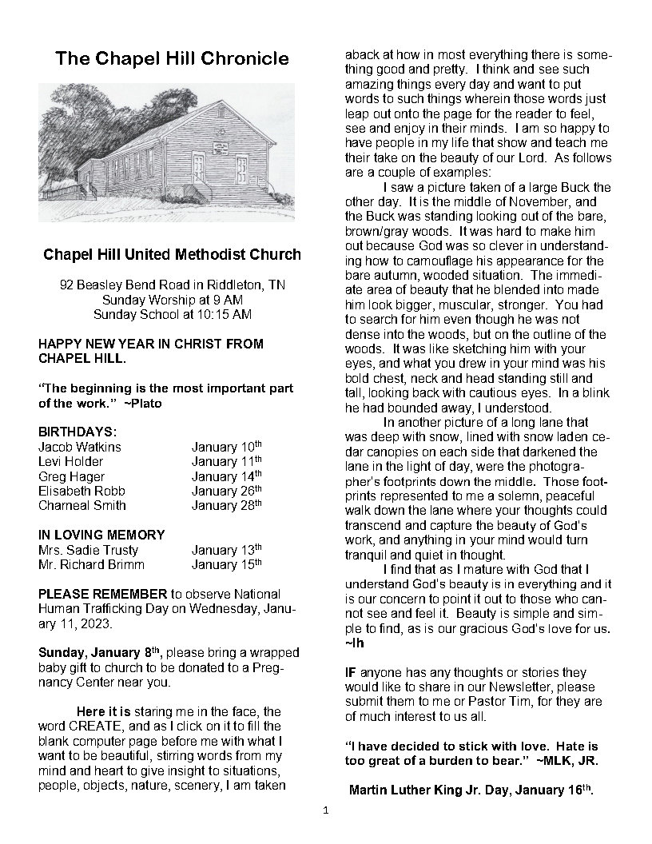
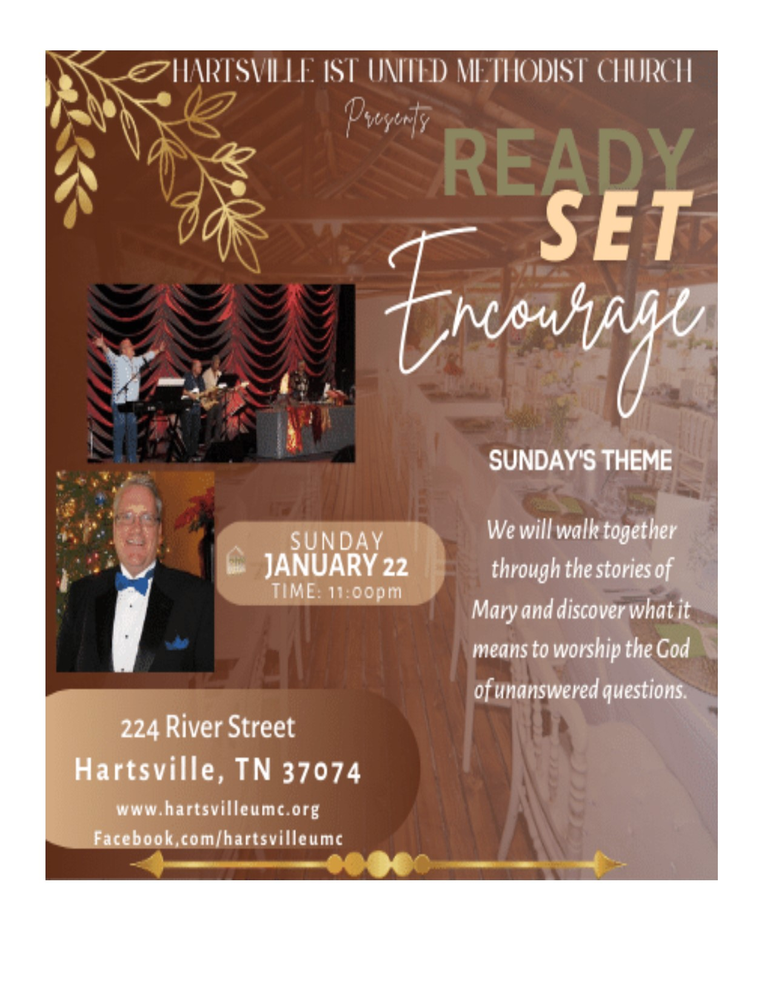

ill United Methodist Church
92 Beasley Bend Road in Riddleton, TN
Sunday Worship at 9 AM
Sunday School at 10:15 AM
August nights: A Sturgeon moon, Peridot
stars, milky clouds stretching across the
sky, a few lightning bugs jumping around
just to tease us with the thought of
summer, even though God’s bountiful
harvest is almost upon us. Last chance to
fulfil your dreams of this summer.
BIRTHDAYS:
Molly Damron August 5
th
Makaila Richardson August 5
th

Linda McDonald August 9
th
Brandon Maberry August 9
th
Jere Draper August 11
th
Don Grandstaff August 18
th
Veria Hensley August 22
nd
Madison Robb August 23
rd

IN BEAUTFUL MEMORY OF:
Beverly Lee August 10
th
Ella Haynes August 21
st
Come see Chapel Hill UMC at the Trousdale
County Fair, Aug. 5 – Aug. 6, 2022.
Chapel Hill UMC would like to take this
opportunity to acknowledge and rejoice in our
new worshipers that have been attending in the
CHUMC sanctuary the past few weeks. They
have brought to our service beautiful music,
lovely smiles and laughter, new and nice
fellowship and their love of the Lord and our
new Pastor and his family. I hope this is the
beginning of a long, loving relationship in Christ
at Chapel Hill. Welcome.
Let us keep in prayer daily our teachers and
students going into the 2022-2023 school year.
Please pray for their safety and that they might
have the best school year ever. Full of no fear,
fun, knowledge, happy recess’ and no failed
tests.
CHUMC says thank you for everyone that
donated food, drinks, donated their time
helping in the Trailer in Smith County and at
Trousdale County High School. To our faithful
customers who remember us year after year.
You are a blessing to us and to the recipients
of every scholarship given. A special thanks
goes out to Mrs. Veria Hensley who prepared
approximately 70 pounds of mashed potatoes
for this 2022 Fair Season. We may have to
present her with a Golden Spud Award
(painted gold, of course). Also, to Mrs.
Barbara Rollins, who works so hard and
faithfully for our missions. We are humbled
year after year by the participation and
dedication of others. This being our 15
th
year
selling Walking Tacos, Hot Roast Beef
Sundaes, etc… First and last, we want to
thank God.
HOW TO COOK PEACHES ON A STOVE:
2 tablespoons of unsalted butter, 2
tablespoons of sugar, 4 large ripe peaches
(pitted and cut into 8 wedges).
In a large skillet melt unsalted butter over
medium heat. Stir in sugar.
Add peaches, cook, stirring until sugar has
dissolved and peaches are warmed through
and coated. 2-5 minutes. Serve immediately.
Don’t forget the Vanilla Ice Cream!!!
“My comfort in my suffering is this: Your
promise preserves my life.”
Now everyone has an activity available during Sunday School time at 10 AM. The choices are as follows:

Class Ages Leader Location
Nursery Newborn – 3yo Gilda Downstairs nursery
Youth Group 4yo- 5th grade Kathy R. Youth Classroom
Brunch and Bibles 6th-12th grades Kayla J. Fellowship Hall
Epworth Class 18yo and up Leah B. Young Adult Room
John Wesley Class 18yo and up John O. Upstairs Class rm

Sunday School
For All Ages

Special Guest

Sunday, January 22 both congregations are pleased to welcome a special guest. Rev. Dr. Phil Jamison will be here to share an important word from God. Dr. Jameson is a wonderful leader that has served the church in many capacities. He is an ordained elder of the Tennessee Western Kentucky conference, he has taught as a professor at seminary, and he currently serves as the president of the UM Foundation of the Tennessee Western Kentucky Conference. He has an important message to share with the congregation, you do not want to miss it.

A Changing of the Guards.

Each year we elect new leaders for our church. This gives everybody a voice, prevents people from getting burn out, and allows everyone the opportunity to grow through service. We want to thank our leaders of 2022 for such a wonderful job, guiding the church through multiple building renovations, an unexpected pastoral change, and a wonderful year in service to the community for our Lord and Savior. We also want to thank the group of leaders for 2023, for their willingness to serve, their devotion to the body, and their commitment to integrity. These are our church committees and their members for 2023.

Trustees
Chairperson Dana Hessler
Sandra Taylor, Kathy Robertson, Patrick Kelly, Jackie Dillehay, Bill Arnold, Randy Hyatt, Tina Guffey
Staff Parish Relations
Chairperson Kathy Lindsey
Tinker Garrett , Connie Dillehay , Judy Guffey, Barbara Garren, Rannye Robertson, Beth Crabtree, Rob Rickman, John Oliver

Lay Leadership
Chairperson Tim Dunavant
Kathy Dies, Natalie Knudsen, Martha Dawson, Seth Thurman, Kassie Hessler, Alice Satterfield

Finance
Chairperson Paul Knudsen
Financial secretary Betty Gross
Treasurer Dustin Dillehay
Kathy Lindsey, Dana Hessler, Clint Shatterfield , Kathy Dies

Family Ministry
Chairperson Leah Brown
Whitney Dillehay, Leah Satterfield, Tina Hyatt, Kathy Robertson, Brad Jones, Kayla Jones, Jamie Curtis, Kathy Lindsey, Michelena Newman

Worship
Chairperson, Kathy Dies
Natalie Knudsen, Connie Dillehay, Seth Thurman, Barbara Garren, Betty Gross, Judy Guffy, Leah Brown

Fellowship
Chairperson, Natalie Knudsen
Judy Guffey, Connie Dillehay, Betty Gross

Missions
Chairperson, Beth Crabtree
Alice Satterfield, Connie Dillehay, Casey Satterfield, Judy Guffey, Rannye Robertson, Sandra Taylor, Betty Gross, Kathy Dies, Martha Dawson, Barbara Garren

Communications
Chairperson, Kathy Atwood
Dana Hessler, Natalie Knudsen, Travis Brown

Church Council
Chairperson, Clint Satterfield
Chairpersons of all committees are members of council
Church historian John Oliver
Sunday school secretary Betty Rackley
Membership secretary Kassie Hessler
Financial secretary Betty Gross
Treasurer Dustin Dillehay
United Methodist Women president Kathy Lindsey
At-large members
Tinker Garrett , Nancy Garrett, Eleanor Satterfield, Vivian Arnold, Bill Arnold

Lay leader - Kathy Atwood and Lay delegate to annual conference - Kathy Robertson. These two positions are members of the church council and all committees.

All of our meetings are open to anyone with the exception of the staff parish relations committee. Come and join us at all of the other meetings and help us plan for success throughout the year.

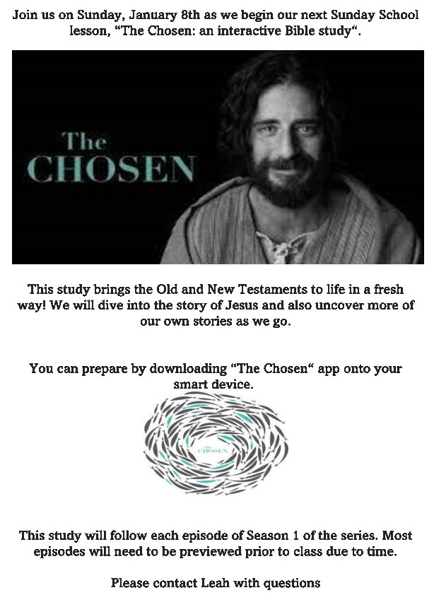

Hartsville First United Methodist Church
224 River Street
Hartsville, TN 37074

Did you know?
Passion Drama

We are hoping to host an adult passion play this year on Good Friday. And we will need lots of help.

Can you help gather and organize costumes? Can you help find or make props? Help build the stage? Can you do make up? Or would you like to be on stage either speaking or non-speaking?

Talk to Pastor Tim to find out more. Don’t wait, it’s a large production so we must get started now.

